**Apache Kafka—Introduction**

Kafka is a high-performance, real-time messaging system. It is an open source tool and is a part of Apache projects.

The characteristics of Kafka are:

Kafka is a distributed and partitioned messaging system that is highly fault-tolerant and scalable. It has been tested to process and send millions of messages per second to several receivers.

.

**Kafka History**

Apache Kafka was originally developed by LinkedIn to handle their log files and later handed over to the open source community in early 2011. It became a main Apache project in October, 2012. A stable Apache Kafka version 0.8.2.0 was released in Feb, 2015 and a stable Apache Kafka version 0.8.2.1 was released in May, 2015, which is the latest version. 102

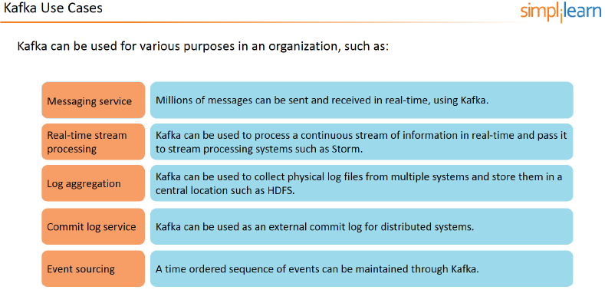

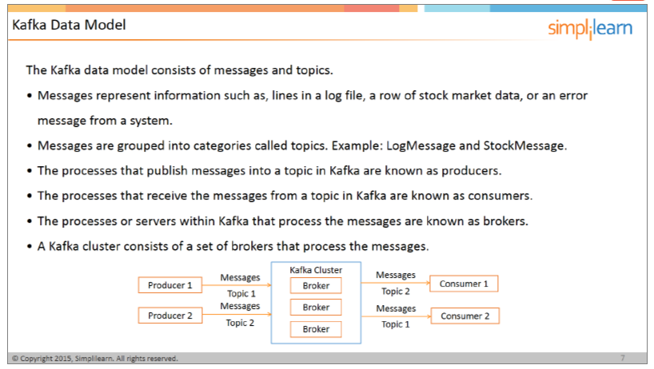

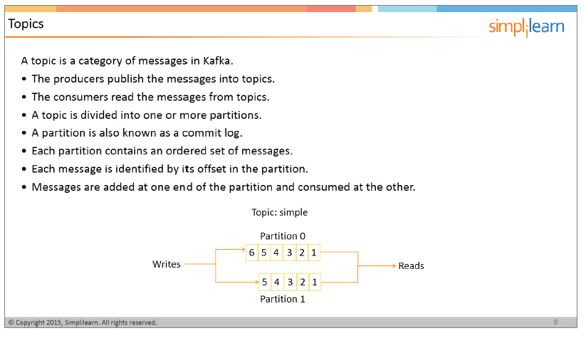

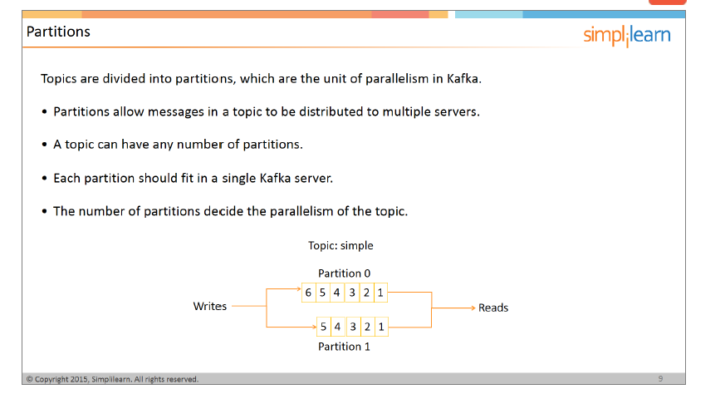

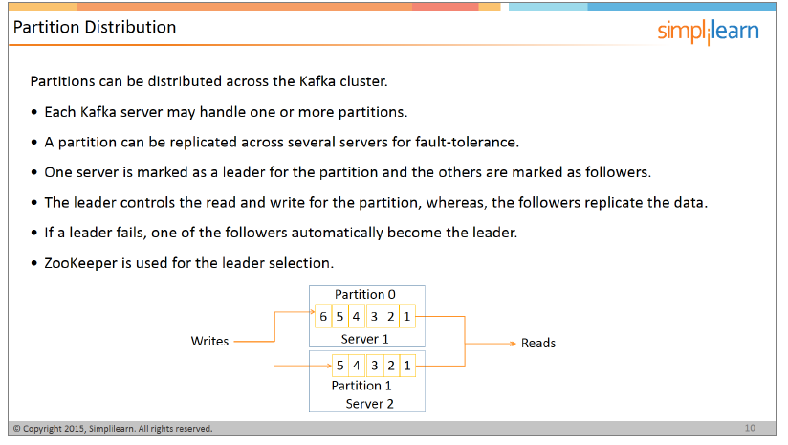

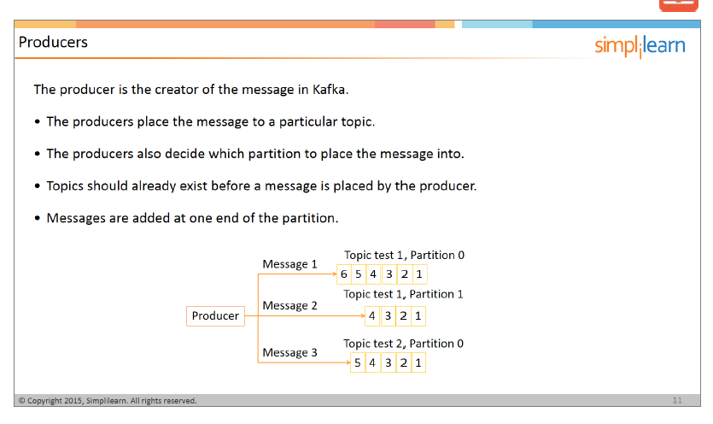

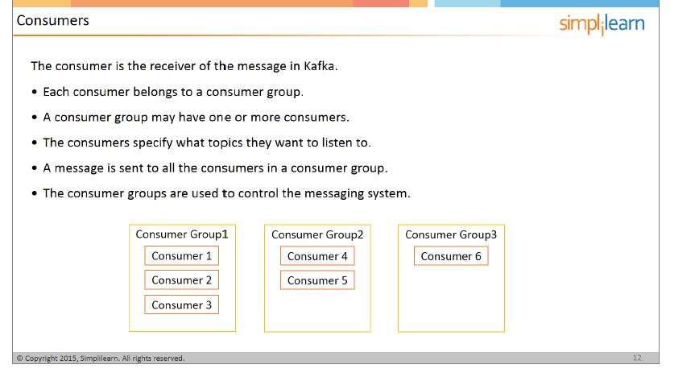

**Kafka Architecture :- ??????**

